Tech That – Education Technology Conference
Thursday 9th and Friday 10th November 2017 – Appleby Park Hotel (Leicestershire)
Package 1: Exhibition Stand - £299
Trestle table and table cloth in exhibition hall for conference on Friday 10th November. Access to Wi-Fi and electrical sockets. Entrance to conference room on Friday 10th November and catering provided for up to two staff members. Listing in event programme.

Package 2: Event Sponsor - £499
Logo on all promotional material and advert on conference website page. Pre-event promotion via social media and email mailshots. Twin or double room provided at Appleby Park Hotel on the evening of Thursday 9th November. 5 minute presentation slot in which to demonstrate your product live to delegates at the Thursday evening event. Food provided for two members of staff on the Thursday evening. Trestle table and table cloth in the exhibition hall for the conference on Friday 10th November. Room for two pop-up banners or one large banner behind the table. Access to Wi-Fi and electrical sockets. Entrance to conference room and catering provided for two staff members.

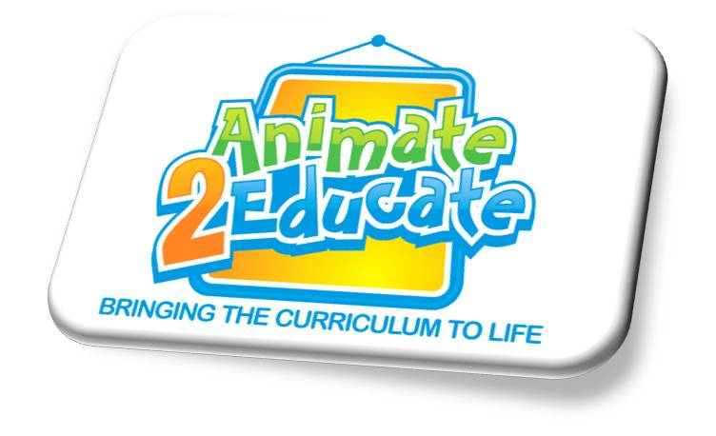
* Additional hotel rooms are available priced at £59 each, should two staff members be attending and require their own rooms, or if you require exhibition stand and accommodation only.
Tech That Education Technology Conference - Booking Form
Thursday 9th and Friday 10th November 2017 – Appleby Park Hotel (Leicestershire)

Company Name
Contact Name
E-mail Address
Package Option
Number of Additional Hotel Rooms (£59 each)

Total Cost | £

* Please note that VAT at 20% is added to all of the above prices

Complete you booking form below and email to info@animate2educate.co.uk or post to Animate 2 Educate Ltd, 20 Windsor Court, Sheriffs Close, Felling, Gateshead, Tyne and Wear, NE10 9UA.

For more information visit the ‘Courses & Conferences’ section of the Animate 2 Educate website www.animate2educate.co.uk or call (0191) 469 2932 / 07921 069 489.

