Plagiarism and Copyright
Name(s):
Learning Objectives:
- To become familiar with the definition of plagiarism.
- To identify the consequences of plagiarism.
- To begin to understand simple strategies to avoid online plagiarism.
Visit these three websites (Use CTRL + LEFT CLICK) that all give information about the Titanic:
- http://www.bbc.co.uk/history/titanic
- http://www.history.com/topics/titanic
- http://www.eyewitnesstohistory.com/titanic.htm
Copy and paste an interesting paragraph (of about three or four sentences) into the text box below:

Copy and paste the full URL (web address) of the site that you have used into the box below:

Now write the above paragraph in your own words. Try to include the key facts and information, but make sure that you are not just copying full blocks of text.

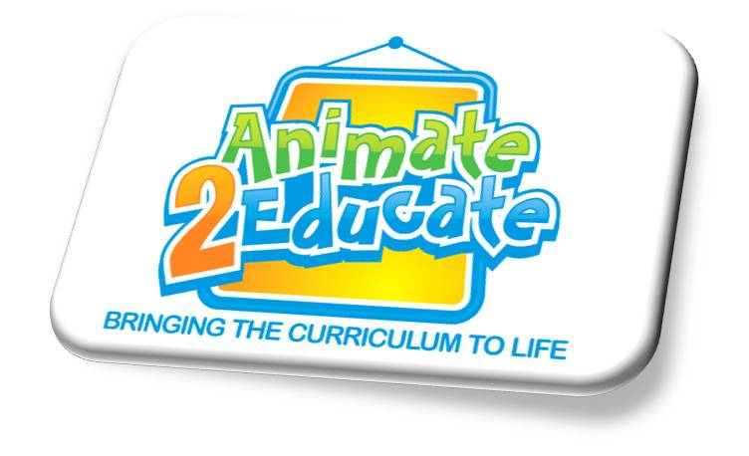
Use Google images to find a picture of the Titanic. Make sure that you use Search Tools > Usage Rights to find an image that has been labelled for reuse. Paste your picture of the Titanic in the box below and then copy and paste the URL (web address) of where you have got the image from.

